

1st Year 1nd Semester BSc. (Hons) Final Examination 2019

Institute of Information Technology

**Jahangirnagar University**

Savar, Dhaka-1342

ICT 1100: Course Viva

***Digital clock***

Submitted To:

**Dr M Shamim Kaiser**

Associate Professor

Institute of Information Technology

Jahangirnagar University

**DECLARATION**

This project report is submitted to the Institute of Information Technology, Jahangirnagar University, Savar, Dhaka in partial fulfillment of the requirements for having the B.Sc (Hons.) degree in IT. This is also needed to certify that the project work is under the 1st Year 1nd Semester course of the IIT “ICT-1100: Course Viva”. So, we are here declaring that this project report has not been submitted elsewhere for the requirement of any kind of degree, diploma or publication.

Yeasmin Aktar Mitu MD Shakil Hossain MD Asaduzzaman  
 192309 192340 180203

**ACCEPTANCE**

This project report is submitted to the Institute of Information Technology, Jahangirnagar University, Savar, Dhaka in partial fulfillment of the requirements for having the B.Sc. (Hons.) degree in ICT.



**Dr M Shamim Kaiser**

Associate Professor

Institute of Information Technology (IIT)

Jahangirnagar University

Savar, Dhaka-1342, Bangladesh

**ACKNOWLEDGEMENTS**

First of all we would like to thank the Almighty for giving us the opportunity to complete this work successfully. Our acknowledgement is meant to express our sincere gratitude to all those people who have been associated with this project and have helped us with it and by sharing their experiences and valuable opinions through which we received the required information crucial for our project. We are thankful to our parents for their relentless support. Most importantly we are grateful to our honourable supervisor who took time out to guide us and provide us with all the necessary materials and sufficient knowledge that was the major requirement.

Finally, we convey our regards to our honourable teacher **Dr M Shamim Kaiser** Sir for giving us the opportunity to learn the subject particularly practically.

**ABSTRACT**

This is very useful program in C language for the teachers. In this program teachers can easily see the digital clock. It will also calculate time. In a word it is a very useful and simple program for digital clock. Admin can use the information when it is needed.

**CONTENTS**

**Chapter 1** Introduction………………………………...…….6-7

* 1. About Clock
  2. Why Digital Clock?
  3. Objectives

**Chapter 2** Methodology………………………………….….8-9

2.1 Algorithm

2.2 Flowchart

**Chapter 3** Result……………………………………………10-11

**Chapter 4** Conclusion and Future work…….……….……...12-13

4.1 Conclusion

4.2 Future work

References…………………………………………………….13-13

**Chapter 1**

**Introduction**

* 1. About Clock:

A **clock** is an instrument used to measure, keep, and indicate [time](https://en.wikipedia.org/wiki/Time). The clock is one of the oldest human [inventions](https://en.wikipedia.org/wiki/Invention), meeting the need to measure intervals of time shorter than the natural units: the [day](https://en.wikipedia.org/wiki/Day), the [lunar month](https://en.wikipedia.org/wiki/Lunar_month), and the [year](https://en.wikipedia.org/wiki/Year). Devices operating on several physical processes have been used over the millennia.

Some predecessors to the modern clock may be considered as "clocks" that are based on movement in nature: A [sundial](https://en.wikipedia.org/wiki/Sundial) shows the time by displaying the position of a shadow on a flat surface. There is a range of duration timers, a well-known example being the [hourglass](https://en.wikipedia.org/wiki/Hourglass). [Water clocks](https://en.wikipedia.org/wiki/Water_clock), along with the sundials, are possibly the oldest time-measuring instruments. A major advance occurred with the invention of the [verge escapement](https://en.wikipedia.org/wiki/Verge_escapement), which made possible the first mechanical clocks around 1300 in [Europe](https://en.wikipedia.org/wiki/Europe), which kept time with oscillating timekeepers like [balance wheels](https://en.wikipedia.org/wiki/Balance_wheel).

1.2 Why Digital Clock?

A **digital clock** is a type of [clock](https://en.wikipedia.org/wiki/Clock) that displays the time [digitally](https://en.wikipedia.org/wiki/Digital_data) as opposed to an analog clock, where the time is indicated by the positions of rotating hands.

Because digital clocks can be very small and inexpensive devices that enhance the popularity of product designs, they are often incorporated into all kinds of devices such as cars, radios, [televisions](https://en.wikipedia.org/wiki/Television), [microwave ovens](https://en.wikipedia.org/wiki/Microwave_oven), standard [ovens](https://en.wikipedia.org/wiki/Oven), computers and cell phones. Sometimes their usefulness is disputed: a common complaint is that when time has to be set to Daylight Saving Time, many household clocks have to be readjusted. The incorporation of automatic synchronization by a radio time signal is reducing this problem.

1.3 Objectives:

The principal aim of our project is:

* To calculate time correctly.
* The [24-hour notation](https://en.wikipedia.org/wiki/24-hour_notation) with hours ranging 00–23.
* The [12-hour notation](https://en.wikipedia.org/wiki/12-hour_notation) with AM/PM indicator, with hours indicated as 12AM, followed by 1AM–11AM, followed by 12PM, followed by 1PM–11PM .
* Finally to make the things easier than ever.
* To build a term working experience among student.

**Chapter 2**

**Methodology**

2.2 Algorithm:

Step 1: Start.

Step 2: Enter three variable s, m, h.

Step 3: If s greater than equal 60. Show s=0, m++.

Step 4: Else if m greater than equal 60. Show m=0, h++.

Step 5: Else if h greater than equal 24. Show s=0, m=0, h=1.

Step 6: Else show Error.

Step 7: Print.

Step 8: End.

2.3 Flowchart:

Input s, m, h

s>=60

Yes

No

S=0, m++

Yes

m>=60

No

m=0, h++

Yes

h>=12

No

Error

s=0, m=0, h=1

Print

**Chapter 3**

**Result**

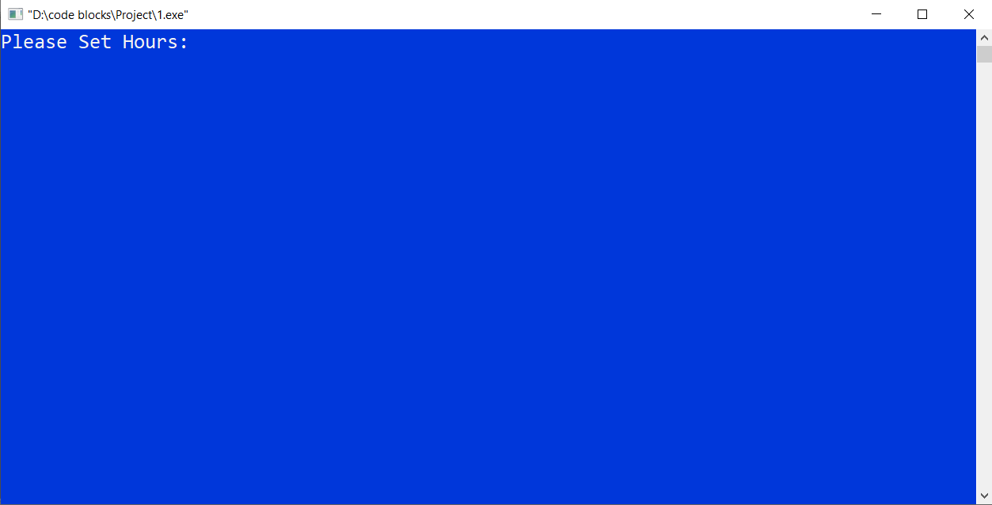

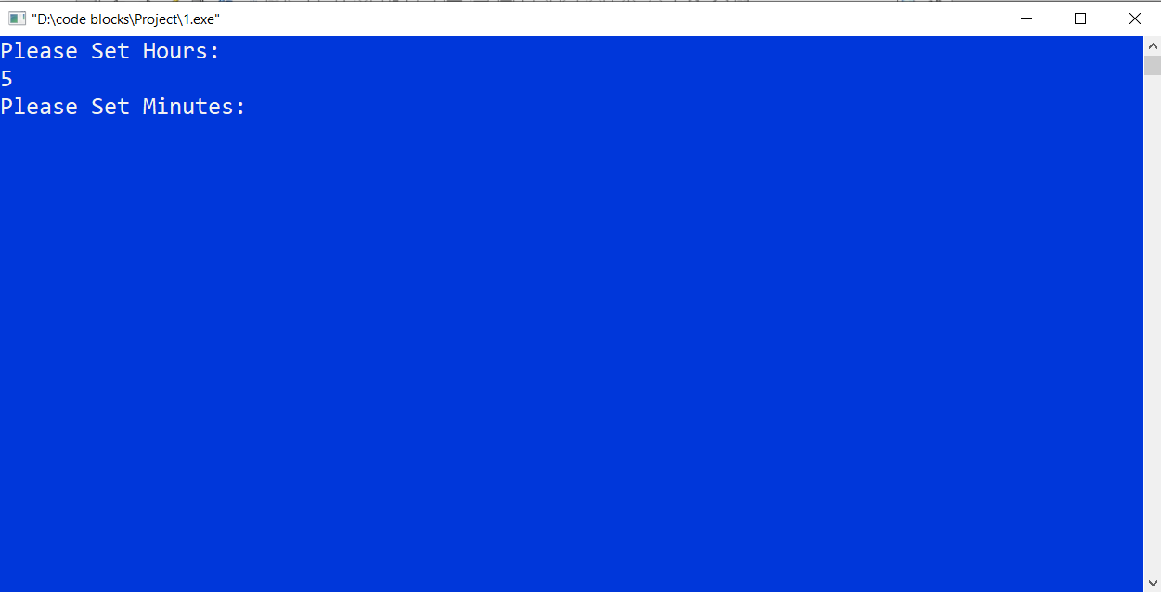

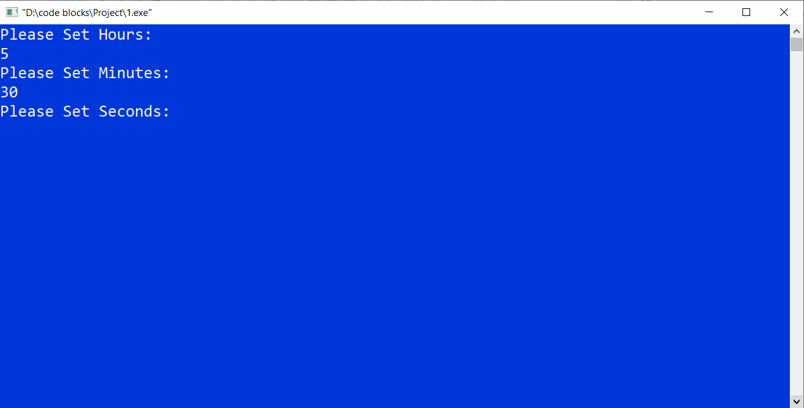

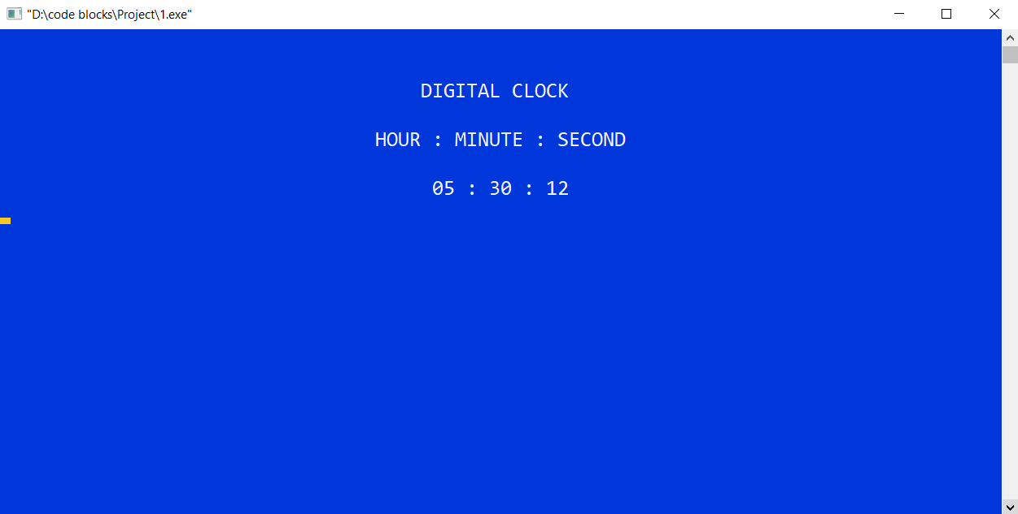

**Chapter 4**

**Conclusion and Future work**

4.1 Conclusion:

Now-a-days different pattern of digital clocks are available in market. Most of them are of very high price and low quality. Many of those cannot provide the time accurately for longer period as those are designed with timer IC’s like 555 timer. Again some digital clocks loss their data whenever the power supply shuts down. But our designed multipurpose digital clock is accurate because of its Real Time Clock module that keeps track of the system time and update. The DS1307 has a built-in power sense circuit that detects power failures and automatically switches to the 3V Li Cell battery supply which is incorporated with the RTC. Most of the digital clock in the market does not cover all the time functions whether our designed digital clock covers all the time options and we will also incorporate the alarm option in next version. However, the Temperature displaying is an additional feature of our smart digital clock. It is possible to develop this system with only USD 7. So this version of digital clock is really a cheap, precise and well featured device for the present market.

4.2 Future work:

* Set Time setting, off and on system.
* Set Date system.
* Set Alarm system.

**References**

1. [www.google.com](http://www.google.com)
2. [www.Wikipedia.com](http://www.wikipedia.com/)
3. [www.youtube.com](http://www.youtube.com)